|  |
| --- |
| Serial No: |
| **2nd Sessional Exam** |
| **Total Time: 1 Hour** |
| **Total Marks: 30** |
|  |
| ________________  **Signature of Invigilator** |

|  |
| --- |
| **SE-4003: Fundamentals of Software Project Management** |
| Tuesday, 7th November, 2023 |
| **Course Instructors** |
| Uzma Mahar |

|  |
| --- |
| **____________________ ____________ _____________ _________________**  **Student Name Roll No. Course Section Student Signature** |

## DO NOT OPEN THE QUESTION BOOK OR START UNTIL INSTRUCTED.

**Instructions:**

1. Attempt on question paper. Attempt all of them. Read the question carefully, understand the question, and then attempt it.
2. No additional sheet will be provided for rough work. Use the back of the last page for rough work.
3. If you need more space, write on the back side of the paper and clearly mark question and part number etc.
4. After asked to commence the exam, please verify that you have FIVE **(05)** different printed pages including this title page. There are total of TWO **(02)** questions.
5. Calculator or any other stuff sharing is strictly prohibited.
6. Use permanent ink pens only. Any part done using soft pencil will not be marked and cannot be claimed for rechecking.

|  |  |  |  |
| --- | --- | --- | --- |
|  | **Q-1** | **Q-2** | **Total** |
| **Marks Obtained** |  |  |  |
| **Total**  **Marks** | **20** | **10** | **30** |

**Question 1**

**Answer the short questions [4*5=20 Marks]**

1. Let consider a system X whose repair time is 4 second and time to fail is 30 second. Find the availability of the given system X.

**MTBF=MTTR + MTTF = 4+30 = 34**

**AVAILABILITY = MTBF/MTBR + MTTR =34/(34+4)=34/38=0.895**

1. Within the time frame of one year, it is expected that if the company hires four employees for the expansion, then the revenue of the company will increase by 50 %, i.e., the revenue benefit will be around $ 250,000. Also, due to the new hiring, the company value of the business will increase, which would result in additional revenue of $ 30,000.The salary of the new employees is estimated to be $160,000.The additional cost of hiring is estimated to be $ 15,000. The cost of additional hardware and software required will come at around $ 25,000. Find the **expansion using Cost-benefit analysis.**

Cost of project = $160,000 + $ 15,000 + $ 25,000 = 200,000

Benefits = $ 250,000 + $ 30,000 = 280,000

CBA=Benefits / Cost = 200000/280000= 0.714

1. Perform the Earned Value Management analysis (CV, SV, CPI, SPI, ETC, EAC, VAC) for the following given scenario:

* Budget 100 $, duration 5 years (60 months)
* At the end of year 4, actual cost 90 $, planned cost 80 $
* Progress 75% (earned value 75 $)

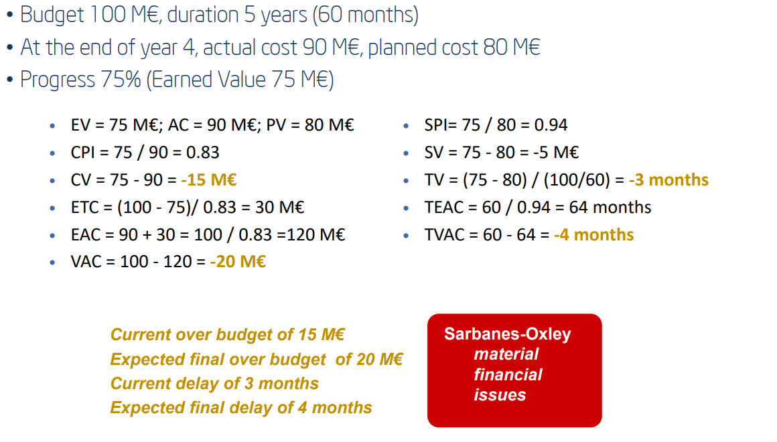

1. Itemize the dimensions of software feasibility and discuss the need it.

30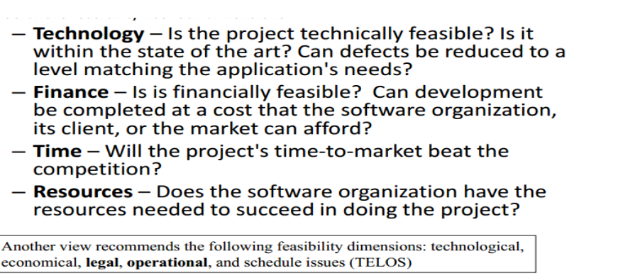

**Question 02 [10 Marks]**

Dr. X, a recent graduate from a medical university, is starting her medical practice in a small town. She is planning to hire a receptionist. She approaches software company Y to build a software system to manage the patients’ appointments. The following is her problem description.

When a patient calls for an appointment, the receptionist will ask the patient’s name or patient’s ID number and will check the calendar and will try to schedule the patient as early as possible to fill in vacancies. If the patient is happy with the proposed appointment, the receptionist will enter the appointment with the patient name and purpose of appointment. The system will verify the patient name and supply supporting details from the patient records, including the patient’s ID number.

 After each appointment the Dr. X will mark the appointment as completed, add comments, and then schedule the patient for the next visit if appropriate. The system will answer queries by patient name, by patient ID and by date. Supporting details from the patient’s records are displayed along with the appointment information. The receptionist can cancel appointments. The receptionist can print out a notification list for making reminder calls 2 days before appointments. The system includes the patient’s phone numbers from the patient records. The receptionist can also print out daily and weekly work schedules with all the patients. **The assumed complexity level for all domain will be average and its weights are given below.**

|  |  |  |  |  |  |
| --- | --- | --- | --- | --- | --- |
| Domains | EI | EO | EQ | EIF | ILF |
| Average | 4 | 5 | 4 | 7 | 10 |

Determine the **function point** for the given system. To calculate the **value adjustment factor** consider all 14 factors as an average with weight 3. Based on the function point analysis determine the **size of given system** by assuming the given system will be developed in c # language. (59 lines per FP).

